Design: Half Hourly Report Transmission to OPRA

Overview

Current processing
New functionality.

New requirement
CBOE needs to send report to OPRA every half an hour. MarketDataReportService is used to gather the data. This service creates a struct called OptionsHalfHourlyReportStruct. Half hourly report for OPRA is created from this struct.
The Half Hourly Report for OPRA includes the total traded volume by category. The categories in this are
- Equity
- Composite
- Index
These reports are transmitted to OPRA via COPP every half an hour.

The transmission will start at 7:30:00 and ends at 15:30:00 with time interval of 30:00 min between each report. The reports generated will be cumulative. Training class and industry test class (if any) need to be excluded while calculating total volume for Equity, Composite and Index category. The system should have functionality to configure/ parameterize start and end time for the reports. The transmission should be aborted at 16:30:00. System should have a mechanism for doing handshake with COPP. Communication protocol between CBOEDirect and COPP is application to application/CORBA interface.
System needs to send a struct to COPP. Currently TPF sends this message to COPP in EBCDIC format.
On expiration day the end of sale may cross 15.30.00, irrespective, the last half hourly report is sent at 15.30.00.

Scope
Scope of this design document is limited to creating & sending report to OPRA from the pre-populated OptionsHalfHourlyReportStruct.

Assumptions
- The shell script will be common for Half Hourly NewsWire, HVOL and Half Hourly OPRA
- There will be no createHalfHourlyReport and sendHalfHourlyReport shell for OPRA.
- No report will be persisted to disk

Implementation

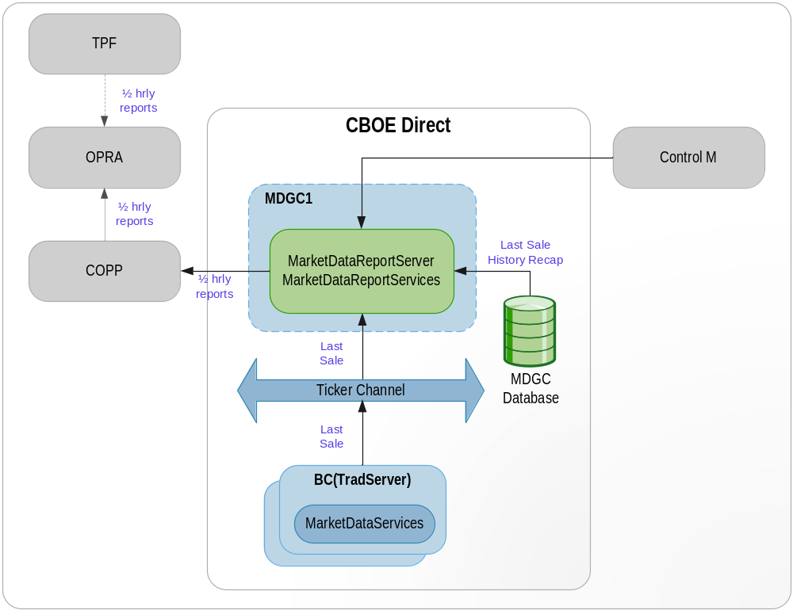
1. Half Hourly Report for OPRA Flow

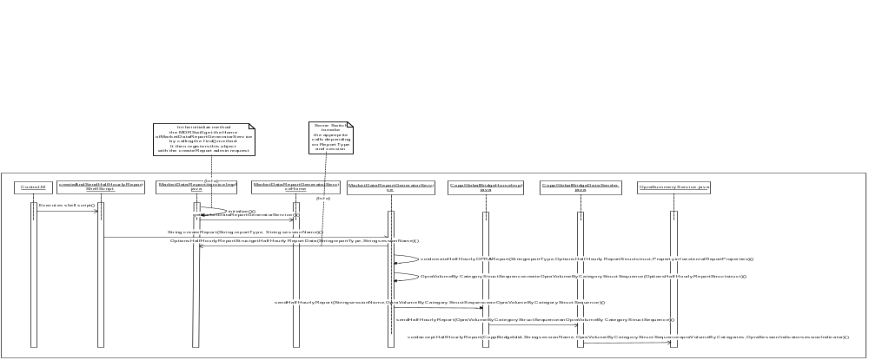
- MarketDataReportGeneratorService is a different service running on MarketDataReportServer. This service is responsible for formatting of different kind of reports.
- MarketDataReportService calls the find() method of MarketDataReportGeneratorServiceHome which returns the object of MarketDataReportGeneratorService. It registers this object with the ar command ‘createReport’ in the initialize method.
- Control-M executes createAndSendHalfHourlyReport shell script that takes the following parameters
  - Report Type
  - Session Name – W_MAIN (e.g.)
Report Type | Parameter 1 (Report Type) Value | Parameter 2 (Session Name) Value
HALF_HOURLY_OPRA | 1 | W_MAIN
HALF_HOURLY_NEWS_WIRE | 2 | W_MAIN
END_OF_DAY_OPRA | 3 | W_MAIN
END_OF_DAY_NEWS_WIRE | 4 | W_MAIN
HVOL | 5 | W_MAIN
HALF_HOURLY_NW_OPRA | 12 | W_MAIN
HALF_HOURLY_OPRA_HVOL | 15 | W_MAIN
EOD_NW_OPRA | 34 | W_MAIN
HALF HOURLY_NW_OPRA_HVOL | 125 | W_MAIN

- This shell script calls the ar command 'createReport’ which calls ‘createReport’ method of MarketDataReportGeneratorService.
- createReport method of MarketDataReportGeneratorService calls back the MarketDataReportService to get the OptionsHalfHourlyStruct depending on the reportType (For reportType - 1,2,5,12,15,25,125). For this, createReport method of MarketDataReportGeneratorService calls find method of MarketDataReportServiceHome which returns the object of MarketDataReportService. On this object, it calls getHalfHourlyReportData method of MarketDataReportService. This method creates the OptionsHalfHourlyReportStruct and returns the struct. Half hourly NewsWire Report, EOD NewsWire Report and Half Hourly OPRA report will be created from this struct. However, the EOD report to OPRA will be created from another struct.
- It then creates the PropertyInfo info for that session and report type.
- createReport method of MarketDataReportGeneratorService then calls the private method createHalfHourlyOPRAReport passing the reportType, OptionsHalfHourlyReportStruct and Propertyinfo info for that session.
- createHalfHourlyOPRAReport then calls createOpraVolumeByCategoryStructSequence of MarketDataReportGeneratorService. This method returns the OpraVolumeByCategoryStructSequence populated with the data required for OPRA Half Hourly Report from OptionsHalfHourlyReportStruct.
- createHalfHourlyOPRAReport then calls sendHalfHourlyReport method of CoppGlobalBridgeHomeImpl passing the sessionName, OpraVolumeByCategoryStructSequence.
- sendHalfHourlyReport of CoppGlobalBridgeHomeImpl calls sendHalfHourlyReport of CoppGlobalDataSender.

2. IDL Changes

IDL changes For Copp that the MarketDataReportServer will use
File location: server/idl/OpraService.idl
Method in bold is new.
Interface OpraSummaryService {
void acceptBeginSummary(String id, String sessionName, int totalClasses, char sessionIndicator)
void acceptSummaryData(String id, String sessionName, OpraSummaryReportStruct[] block)
void acceptTotals(String id, String sessionName, int totalVolume, int totalOpenInterest);
void acceptEndSummary(String id, String sessionName, char sessionIndicator)
void acceptEndOfReporting(String id, String sessionName, String message, char sessionIndicator)
void acceptTextMessage(String id, String sessionName, String message, char sessionIndicator)
void acceptHalfHourlyReport(in CoppBridgeId id, in string sessionName, in OpraVolumeByCategoryStructSequence opraVolumeByCategories, in OpraSessionIndicator sessionIndicator)
raises(
exceptions::SystemException,
exceptions::CommunicationException,
exceptions::AuthorizationException
);
}

struct OpraVolumeByCategoryStruct {
short underlyingCategory ; // product category e.g. composite,index etc
long totalVolume;
string timeStamp; // In HHMM format
};
typedef sequence < OpraVolumeByCategoryStruct > OpraVolumeByCategoryStructSequence;

File location: server/idl/ MarketDataReportService.idl
VolumeByCategoryStructSequence getVolumesByCategory(in cmiSession::TradingSessionName sessionName)
raises(

exceptions::SystemException,
exceptions::CommunicationException,
exceptions::DataValidationException,
exceptions::AuthorizationException,
exceptions::NotFoundException
);

3. Interfaces and Classes
Interfaces:
- com.cboe.interfaces.businessServices.MarketDataReportGeneratorServiceHome.java : Add the following methods
- find
- create

- com.cboe.interfaces.businessServices.MarketDataReportGeneratorService.java : Add the following methods
- String createReport(String reportType, String sessionName)

Classes:
- com.cboe.businessServices.marketDataReportService.MarketDataReportGeneratorServiceHomeImpl.java
- find: returns the MarketDataReportGeneratorService object
- create: creates and returns the MarketDataReportGeneratorService object
- goSlave
- goMaster
- initialize: Loads the properties from the MarketDataReportGeneratorService.xml file

- com.cboe.businessServices.MarketDataReportGeneratorServiceImpl.java : Add the following methods
void createHalfHourlyOPRAReport (String reportType, OptionsHalfHourlyReportStruct struct,Propertyinfo externalReportProperties)
This method creates and sends the report to OPRA.
OpraVolumeByCategoryStructSequence createOpraVolumeByCategoryStructSequence (OptionsHalfHourlyReportStruct struct)
This method creates OpraVolumeByCategoryStructSequence from OptionsHalfHourlyReportStruct.

- com.cboe.businessServices.marketDataReportService.MarketDataReportServiceImpl.java
getHalfHourlyReportData(int reportTypeIntVal, String sessionName)
This method creates the OptionsHalfHourlyReportStruct

- com.cboe.externalIntegrationServices.coppBridge.CoppGlobalBridgeHomeImpl.java :
This class contains the code to send the report to OPRA
public String sendHalfHourlyReport(String sessionName, OpraVolumeByCategoryStructSequence anOpraVolumeByCategoryStructSequence)
- com.cboe.externalIntegrationServices.coppBridge. CoppGlobalBridgeDataSender.java:
sendHalfHourlyReport ( OpraVolumeByCategoryStructSequence anOpraVolumeByCategoryStructSequence)

- com.cboe.interfaces.externalIntegrationServices. OpraSummaryService.java
void acceptHalfHourlyReport( CoppBridgeId id, String sessionName,
OpraVolumeByCategoryStructSequence opraVolumeByCategories,
OpraSessionIndicator sessionIndicator)

Logging
Informative messages will be logged at the beginning and end of each important method.

Exception Handling
All the exceptions will be propagated to the top level i.e. the method that is called from the ar command. This method will then log the exceptions (Log.exception) and return appropriate status from the method.

Scripts(2)

createAndSendHalfHourlyReport
This is a wrapper script for the admin request to createHalfHourlyReport which will create and send the struct (OpraVolumeByCategoryStructSequence) to OPRA.

The following variable will be set in the script
- Last report transmission time (15.30)

In case of OPRA, if user tries to run script “createHalfHourlyReport” or “sendHalfHourlyReport”, then message will be displayed to user such as “For OPRA, Use createAndSendHalfHourlyReport”.

Database(.5)
None

SetContext(.125)
None

XML/DTD(.5)

server\properties\xml\CoppGlobalBridgeHome.xml
- server\properties\dtd\CoppGlobalBridgeHome.dtd
New tag "sendReport” added which will take value “true” or “false”.
Homes/Services(2)
MarketDataReportServiceHome.java
MarketDataReportServiceImpl.java
MarketDataReportGeneratorServiceHome.java
MarketDataReportGeneratorService.java
CoppGlobalBridgeHomeImpl.java

ImplPlan(.5)
In server\properties\xml\CoppGlobalBridgeHome.xml, set value for “sendReport” for the session to “true” or “false”. “false” will cause HH Report generation and log it. But, report will not be sent to COPP. “true” will cause HH Report generation, log and will be sent to COPP.

PerformanceTestingProcedure(1)
None

TestingProcedure(1)
None

OperatorProcedure(.5)
???

Fallback/Failover
None

GUI Design
Trade GUI has to be modified.

Queries
- Are we going to have different AR commands for Half Hourly Reports to OPRA and NewsWire?
Ans: In case of OPRA, existing script “createAndSendHalfHourlyReport” will create and send the HH report to OPRA. If user tries to run script “createHalfHourlyReport” or “sendHalfHourlyReport”, then message should be displayed to user such as “For OPRA, Use createAndSendHalfHourlyReport”.
This script calls ‘createReport’ method of “MarketDataReportGeneratorService”.
Comments:
- Add common variable in setContext.main for start time(7:30 am) and end time(15:30 pm) for Half Hourly Report.
- Add common variable in setContext.main which will used to decide whether ar command for Report needs to be executed or not?
- No new interface such as “ProductTypes” are required to add in opraservice.idl.

Modified Files:
